**05. Deploy Kubernetes Manifests & Test & CleanUp**

--- <https://github.com/stacksimplify/aws-eks-kubernetes-masterclass/tree/master/10-ECR-Elastic-Container-Registry-and-EKS>

--- in this lecture, we are going to do the kubernetes manifests deployment.

**Deploy the kubernetes manifests**

**# Deploy**

--- **kubectl apply -f 02-kube-manifests/**



**# Verify**

--- **kubectl get deploy**

--- **kubectl get svc**



--- **kubectl get pods**

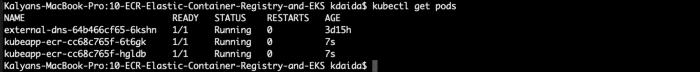

--- **kubectl get ingress**



**Access Application**

--- Wait for ALB Ingress to be provisioned

--- Verify Route 53 DNS registration ecrdemo.kubeoncloud.com

**# Get external ip of EKS Cluster Kubernetes worker nodes**

--- **kubectl get nodes -o wide**

**# Access Application**

--- <http://ecrdemo.kubeoncloud.com/index.html>

**Clean Up**

**# Clean-Up**

--- **kubectl delete -f 02-kube-manifests/**